SECTION 1: CONTACT INFORMATION REQUIRED
Requestor must fill out this section
Name: Agency (if applicable): _____ ____ __ __ ___
Mailing Address: _ __________ ____I Phone Number: _________________________________
Date of Request: ___________________________________________

SECTION 2: CASE INFORMATION
Fill out this section regarding case information for research

Civil Family Probate Small Claims
Case #: ___ ___ __ - ___ ___ - ___ ___ ___ ___ ___ ___ Year Petition/Complaint Filed: _________ County Where Filed _________

Name of Party 1:_______________________________________ Name of Party 2: ___________________________________________________
(Person who Filed Case) (Person Filed Against)
Restricted Unlawful Detainer/Eviction (only):
Property Address _ ___________________________

Name/Gender Change (only):
Birth Name: ___________________________________________ New Name: _____________________________________ Date: ________________

Naturalization Records exist from 1906-1957:
Name: __________________________________________________________ D.O.B.: __________________ Origin County: _____________________

SECTION 3: PHOTOCOPIES/CERTIFICATION/AUDIO RECORDINGS
Please check/list the items requesting

Certified Divorce Decree: $15 plus $0.50 per page Certification/Clerk’s Certificate: $40 plus $0.50 per page
Exemplification: $50 plus $0.50 per page Plain Copies *Example: Certified Divorce: $15 plus 2-pages = $16*
Audio Recording - $25 per CD – Dept. #: ______________ Date: ____________ Other: __________________________
Date: Short Title of Document(s) Photocopies: $0.50 per page ________ _________________________________________________
________ _________________________________________________ No. of Pages: ________________
________ _________________________________________________ Certification Fee: _____________
________ _________________________________________________ Total Cost: __________________
Check here if using page 2 or attachment for additional space
Date _________________  Judgment Book and Page Number  ________________ | Clerk’s Initials ____________  Pick-up by: ________________ | Payment Type:  ⎕Cash ⎕Credit Card ⎕Exempt  ⎕Fee Waiver ⎕Check ⎕No Fee
COURT USE ONLY

Additional Documents Request:
_________ ____________________________________________________ Total No. of Pages:
_________ ____________________________________________________ _______________
_________ ____________________________________________________
_________ ____________________________________________________
Additional Cost: _______________

REQUEST SUBMITTAL (may be done in person or via mail)

Mail/In Person: San Francisco Superior Court
400 McAllister Street, Room 103
San Francisco, CA 94102
Attention: Research

In Person payment: Cash, Check, Credit Card
Mailed payment accepted: Check ONLY

*All Mail Requests must include self-addressed stamped envelope
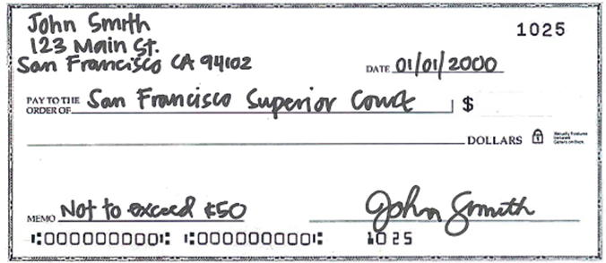
CHECK INSTRUCTIONS
- Make payable to “San Francisco Superior Court”
- Check must include Requestor’s Name and Address
- Include “NOT TO EXCEED $100” in memo line.
- Leave the dollar amount blank and the Court will
determine the final cost.
- If request exceeds $100, staff will contact the
requesting party for additional payment.
Not to Exceed $100.00
- Requests paid by check are held for fifteen (15)
business days before records are released.
OTHER IMPORTANT INFORMATION
- Divorce records are ONLY available in the Filing party’s county of residence at the time of filing.
- A fee of $15 will be charged for searching records or files, for each search longer than 10 minutes.
- Requests will NOT be processed without pre-payment.
- If balance is due at pick up, payment must be made prior to release of records.
- Incomplete requests will NOT be processed.
- Failure to reach you at the number provided may result in additional processing delays and or fees.
- Files ordered from Warehouse will be returned without any notification after 5 business days of files being ready, files will be returned without notifying you. Any subsequent requests, will be treated as a new request, and are subject to additional fees.
- Fee Waivers expire 60 days after final judgment, dismissal or any other document the Court deems final disposition. Fee Waivers do NOT apply to JAVS audio recording.
- Requests for Marriage, Birth and or Death Certificates are NOT available at the Court. Contact the County Clerk (415)554-4950
- If you need a Court Reporter Transcript, please call (415)551-3778 or email transcriptrequests@sftc.org.
You must include the date of the proceedings, the Department and the Court Reporter's name in your request.

GOVERNMENT AGENCIES ONLY
- Must provide agency badge as proof of official acting in official capacity and submit a business card with request.
- Government agencies from another state or third parties acting on behalf of government agencies must pay.
- Any request more than five pages require additional processing time. Staff will contact when ready for pickup.

